Practical task: Article popularity prediction on „Online Online News Popularity Data Set" in RapidMiner following CRISP guidelines

Business Understanding:
Authors and project managers can concentrate on producing
content that consumers appreciate.

Data Understanding:
39797 instances / articles. 61 attributes.
Both integer, continous valued and binominal attributes. 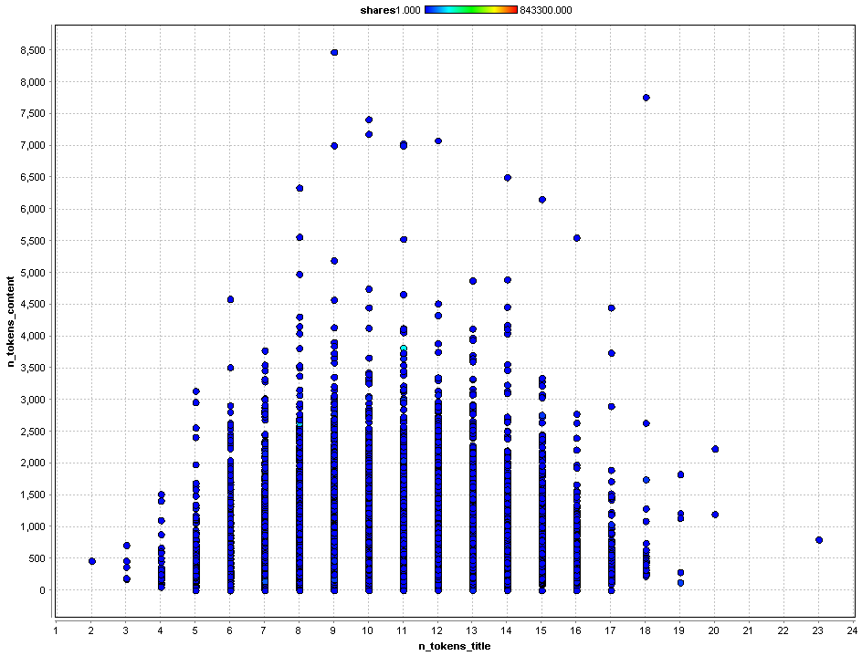
Data Preparation
Useless attributes removed: timedelta, url

Two attributes removed because of correlation with other attributes,
or just not giving any informaton:
n_non_stop_unique_tokens highly correlated with n_unique_tokens.
n_non_stop_words only zero.

Integer attributes converted into continous valued attributes to better work with
modelling tools.

Target variable shares: Number of online shares. Made into binominal using
threshold: > 1400: Popular article, else not popular

Modelling
Goal: Predict if article is popular using X-validation training / validation split.
Using different model building techniques.
Decision Tree
Vizuaisation of decision tree on (all equal configurations)

Full data
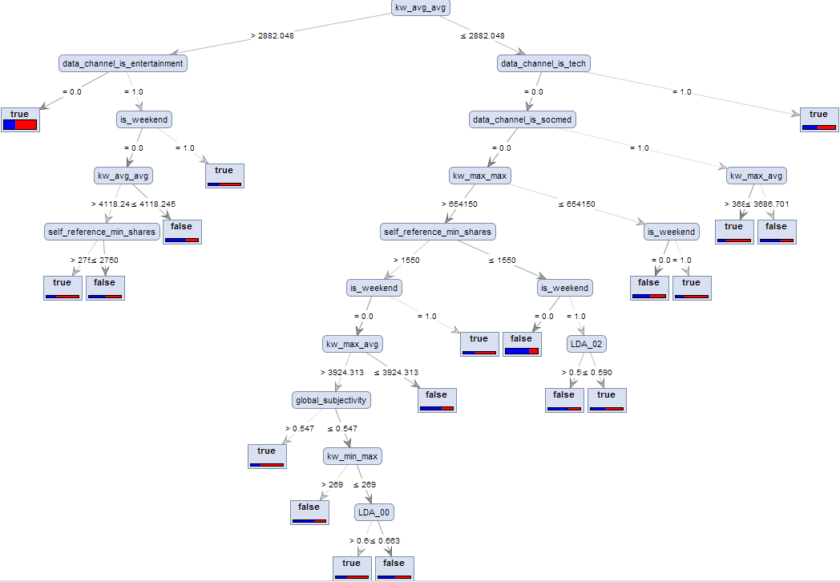

Only binominal attributes
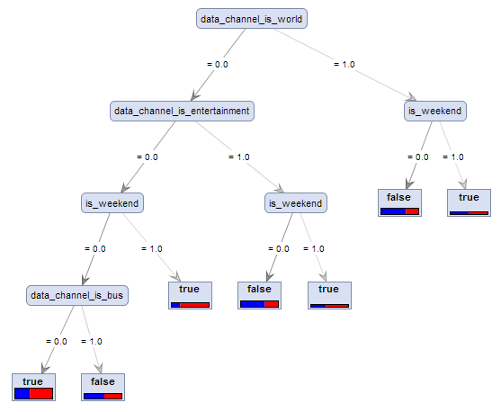

Only continous attributes
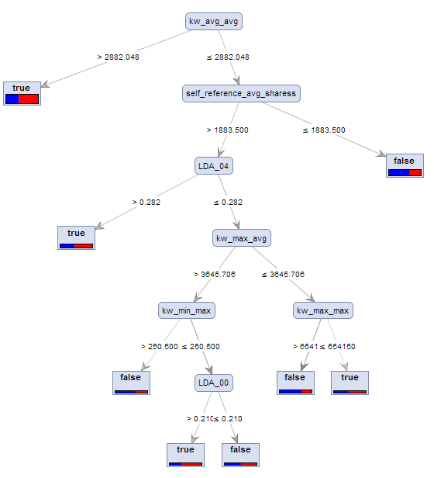
k-NN
Naïve Bayes

Evaluation and Depoyment
Classification accuracy for the different methods compared, using X-validation
with apply model and classification performance. All the data.

Decision Tree
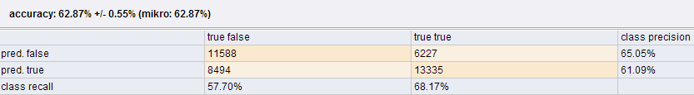
k-NN
Naïve Bayes

